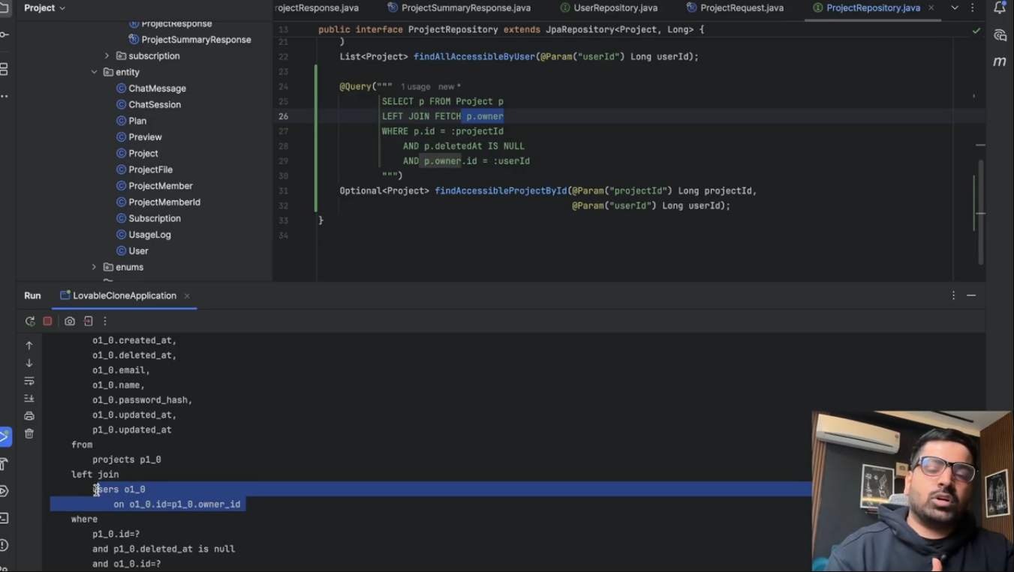
@Query("""
SELECT p FROM Project p
WHERE p.deletedAt IS NULL
AND p.owner.id = :userId
ORDER BY p.updatedAt DESC
"""
)
List<Project> findAllAccessibleByUser(@Param("userId") Long userId);

//Hibernate generates SQL similar to:
SELECT
p.id,
p.name,
p.owner_id,
p.updated_at,
p.deleted_at
FROM project p
WHERE p.deleted_at IS NULL
AND p.owner_id = ?
ORDER BY p.updated_at DESC;

-----------------------------------------------------------------------------------------------------
@Query("""
SELECT p FROM Project p
LEFT JOIN FETCH p.owner
WHERE p.id = :projectId
AND p.deletedAt IS NULL
AND p.owner.id = :userId
""")
Optional<Project> findAccessibleProjectById(@Param("projectId") Long projectId,
@Param("userId") Long userId);

What SQL will Hibernate generate?

It will be similar to:

SELECT
p.*,
u.*
FROM project p
LEFT JOIN users u
ON p.owner_id = u.id
WHERE p.id = ?
AND p.deleted_at IS NULL
AND p.owner_id = ?;

Step 4: LEFT JOIN FETCH p.owner
This is the most important part.
LEFT JOIN FETCH p.owner
Suppose your entity looks like this:
@Entity
public class Project {

@ManyToOne(fetch = FetchType.LAZY)
private User owner;
}
By default:
fetch = FetchType.LAZY
means Hibernate does not load the owner immediately.
Imagine the database contains:

Project Table
id | title | owner_id
10 | AI App | 5

User Table
id | name
5 | Shoaib
Without FETCH:
Project project = repository.findById(10L).get();
Hibernate executes:
SELECT *
FROM project
WHERE id = 10;
Only the project is loaded.
If later you call:
project.getOwner().getName();
Hibernate executes another query:
SELECT *
FROM users
WHERE id = 5;
So you have two database queries.

With LEFT JOIN FETCH
LEFT JOIN FETCH p.owner
Hibernate loads both Project and User together.
Generated SQL is similar to:
SELECT
p.*,
u.*
FROM project p
LEFT JOIN users u
ON p.owner_id = u.id
WHERE ...
Now:
project.getOwner().getName();
does not trigger another SQL query because the owner has already been loaded.
This avoids the N+1 Select Problem.

Why LEFT JOIN?
A normal left join means:
Return the project even if the owner is missing.
Example:

Project
id | owner_id
10 | NULL
Result:
Project returned

Owner = null

In practice, if your database guarantees every project has an owner (@ManyToOne(optional = false)), an INNER JOIN FETCH would produce the same results. Using LEFT JOIN FETCH simply allows rows without a matching owner to be included (unless the WHERE clause filters them out, as it does here).



